Contents

1.0 Introduction 1

2.0 Access to system 3

2.1 Logging in to system 3

2.2 Different levels of access 3

3.0 Customers 5

3.1 Adding customers to the system 5

3.2 View Customers 7

3.3 Edit or delete customers 8

4.0 Ordering 9

4.1 Ordering from supplier 9

4.1.1 Shopping Cart 10

4.2 View Orders in system 11

4.3 View Old Orders 11

4.4 View Delivery Dates 12

4.5 View costs 13

4.5.1 Costs of orders over time 13

4.5.2 View this week’s costs and proportions 14

5.0 Menu Bar 15

5.1 File Menu Items 15

5.1.1 Keyboard Mnemonics 15

5.2 View Menu Items 16

5.2.1 Keyboard mnemonics 16

# Introduction

The bicycle store application is a business support system which can assist store employees in carrying out their jobs. The application is designed to be user friendly and intuitive to use. The purpose of the application is to save the time involved in carrying out business.

The purpose of this document is to demonstrate the functionality provided in the application. The correct method of using the application will be explained using illustrations.

# 2.0 Access to system

## 2.1 Logging in to system

**Figure 2.1: The log in GUI used to protect unauthorised access to the system. Note the error dialogue in the frame on the right where a user has entered an invalid id or password.**

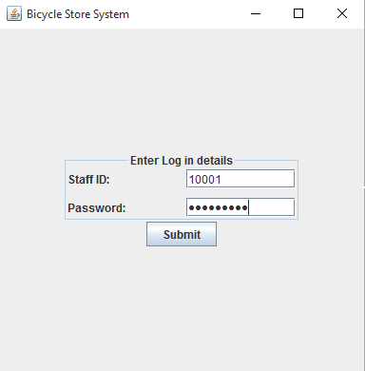 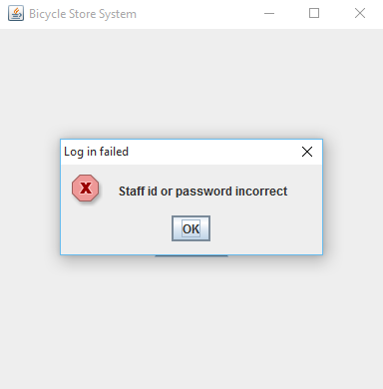

Access to the system is controlled by a log in GUI (graphical user interface). To access the system authorised persons must enter a valid staff number and the correct password for that id.

As illustrated in the image on the left in figure 2.1, the user’s password is not displayed on screen to protect their secure log in details. An attempt to enter the wrong details will result in the dialogue displayed in the image on the right.

## 2.2 Different levels of access

After successful log in different types of employee will have different levels of functionality available to them.

Sales assistants will need to be able to add, view, modify or remove customers from the system. They will also require access to the products in the system. They can therefore view products or add new products. Sales assistants will also have to be capable of generating invoices to complete sales.

Managers on the other hand will require all the functionality provided to sales assistant but they will also require extra functionality. Managers will require functionality to order products from suppliers, viewing current orders, viewing past orders, viewing upcoming delivery dates and viewing costs of orders in system. Managers may need to add new suppliers to the system. Managers will require functionality to manage stock control by viewing graphs and predictions. Managers will also require profit and loss accounting tools.

The different levels of access are illustrated in figures 2.2.1 and 2.2.2. Note the different number of tabs provided for sales assistants or managers. These control the functionality available.

**Figure 2.2.1: The functionality provided to Sales assistants. Note tabs available relate to customers, products and invoicing.**

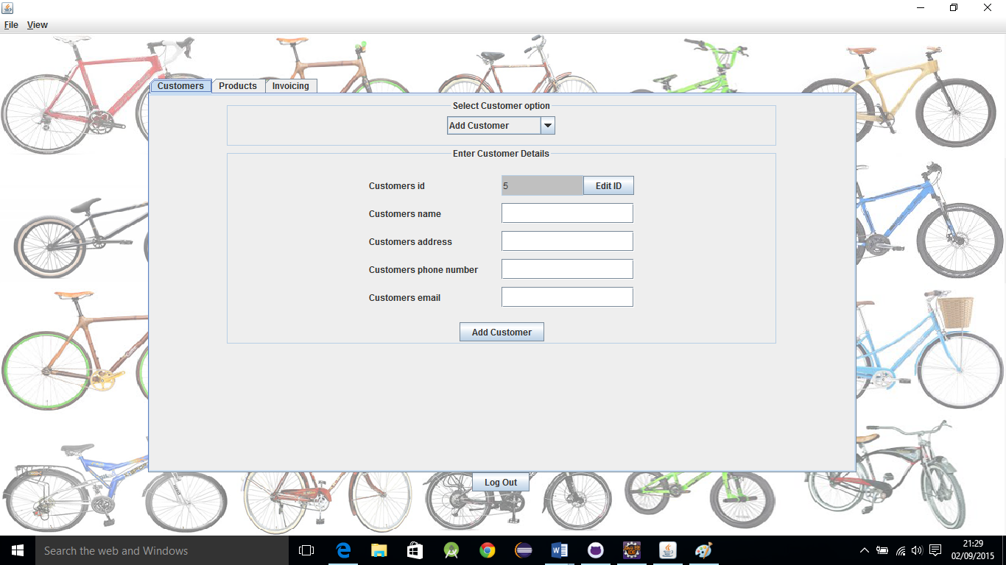

**Figure 2.2.2: The functionality provided to Managers. Note the extra tabs relating to ordering, suppliers, stock control and profit and loss accounting**

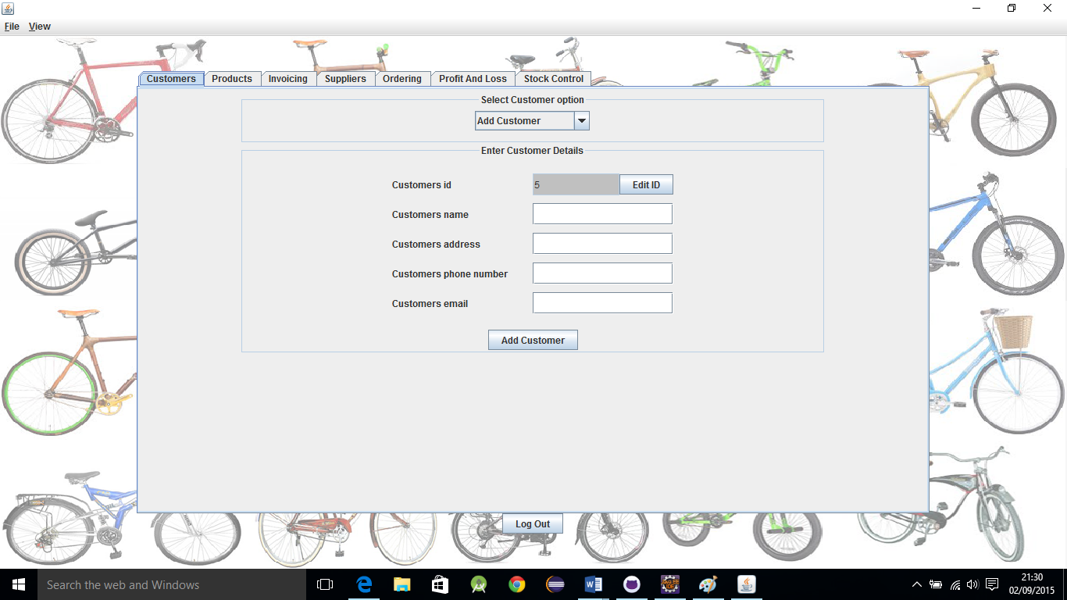

# 3.0 Customers

## 3.1 Adding customers to the system

**Figure 3.1.1: Customer details can be entered into the fields. Note combo box highlighted by the red circle. It is used to select the type of customer operation.**

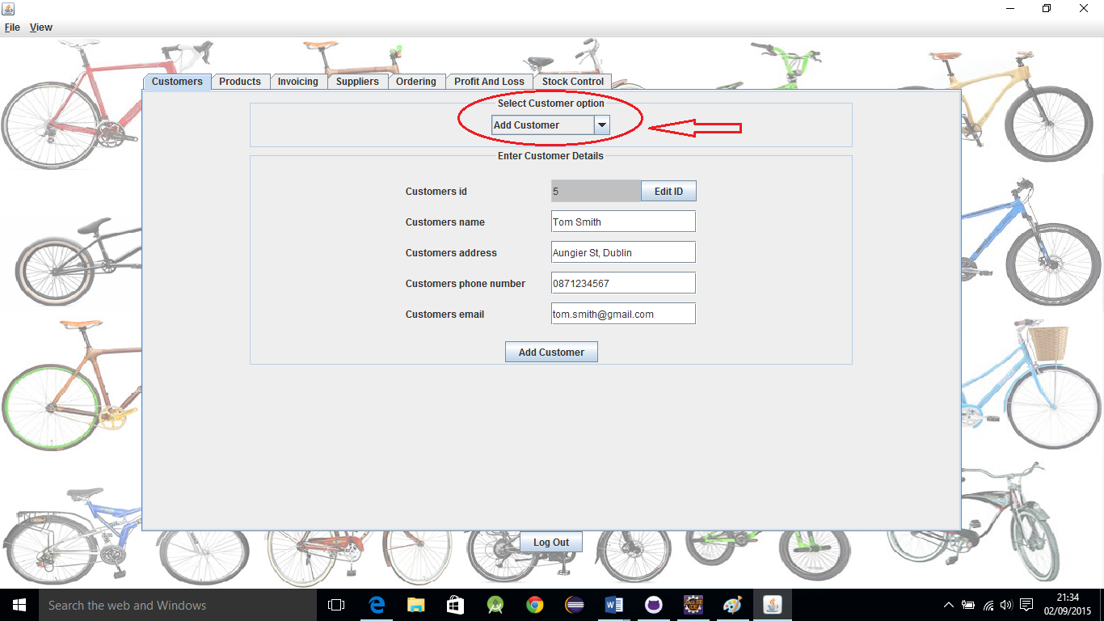

As illustrated in figure 3.1.1 the add customer option must be selected from the combo box at the top of the panel. The customer details form will then be displayed.

The customer’s id is automatically generated. It cannot be altered in the normal way. If for any reason a different id is required, the edit id button can be pressed allowing the user to enter in a different id. This is illustrated in figure 3.1.2.

**Figure 3.1.2: If the edit id button is pressed a new dialogue is displayed allowing the user to enter a different customer id.**

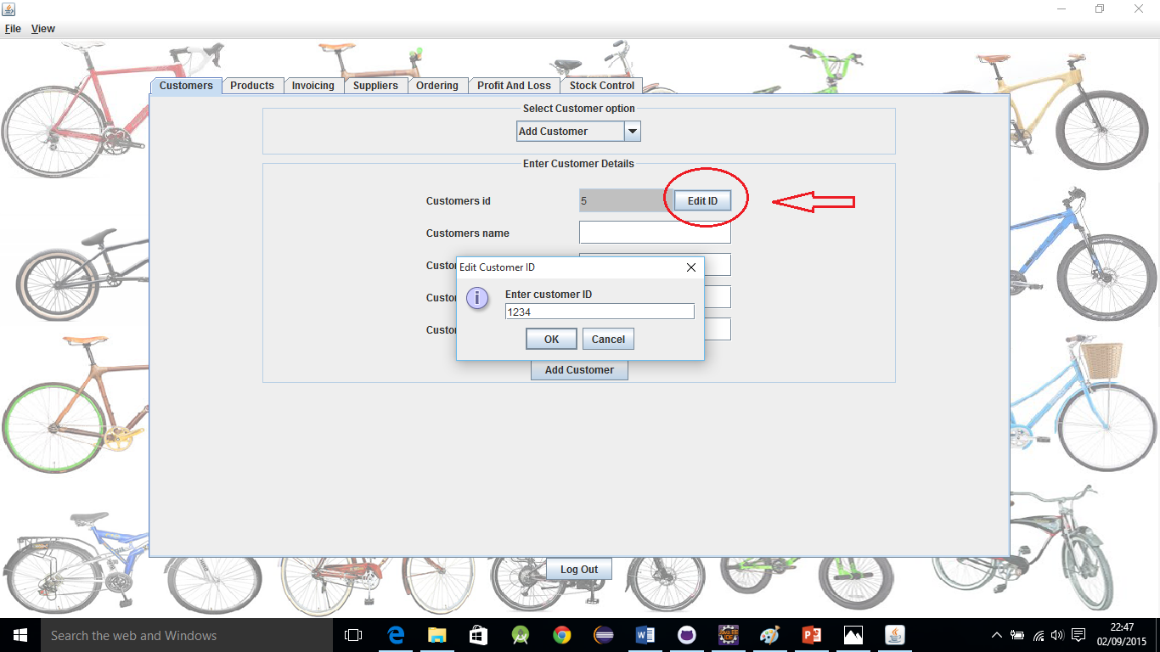

Customer details are submitted to the system by pressing the add customer button below the text fields. A confirmation dialogue is displayed if details are successfully added to system. This is illustrated in figure 3.1.3.

**Figure 3.1.3: The confirmation dialogue if a customer’s details are successfully added to the system**

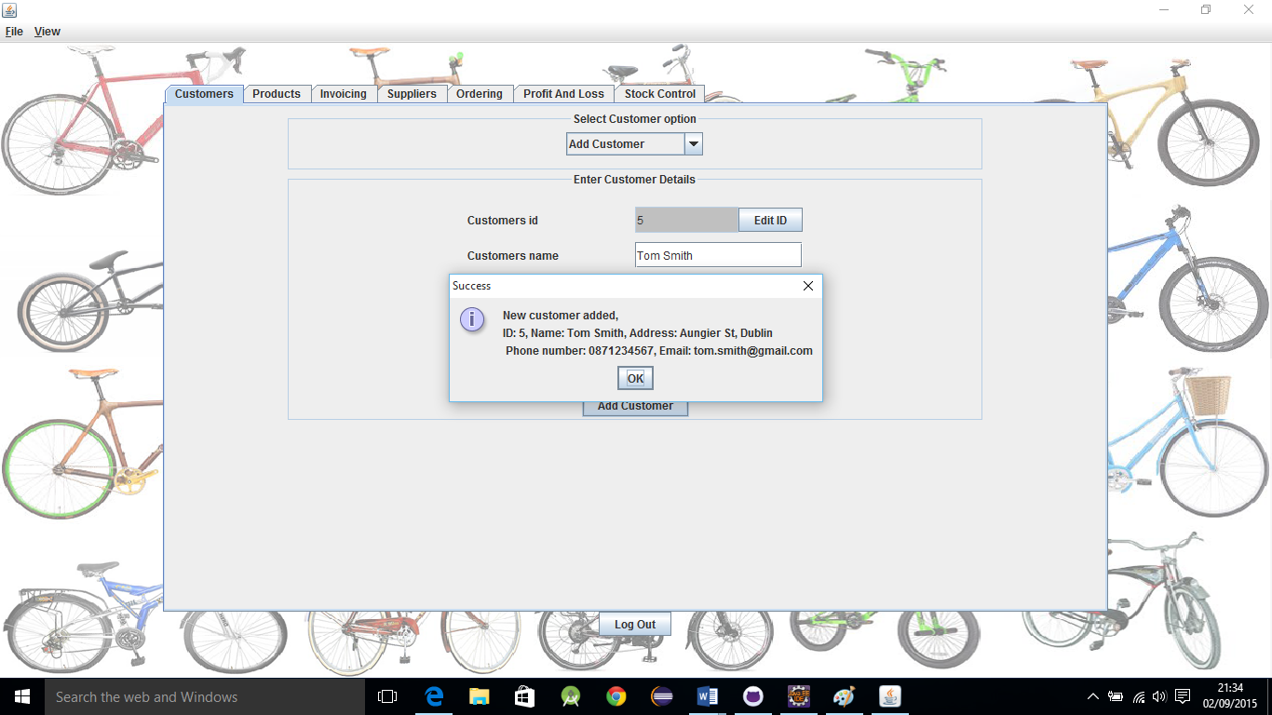

If customer detail fields are not complete, the data is not submitted to the database. An error dialogue will be displayed. This is illustrated in figure 3.1.4.

**Figure 3.1.4: An error dialogue is displayed if all fields are not completed.**

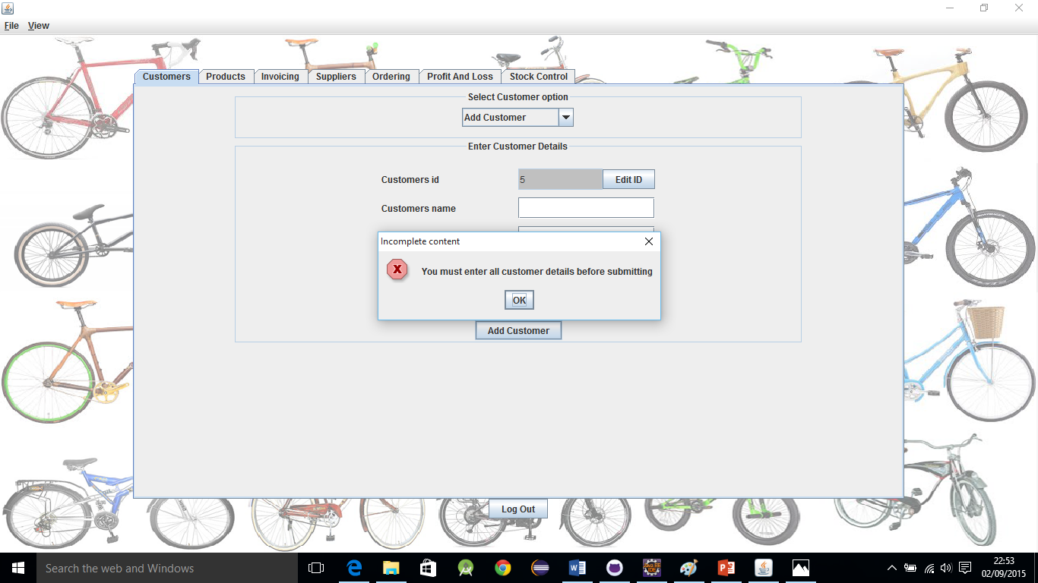

## 3.2 View Customers

To view customers, select the “view customers” option from the combo box. A list of all customers in the system will be displayed on the left hand side. To view the details of any customer, select their name from the list. All details for that customer will be displayed in the grid on the right. This is illustrated in figure 3.2.1.

**Figure 3.2.1: The view customer card. Note the list of customers on the left hand side and customer details grid on right hand side.**

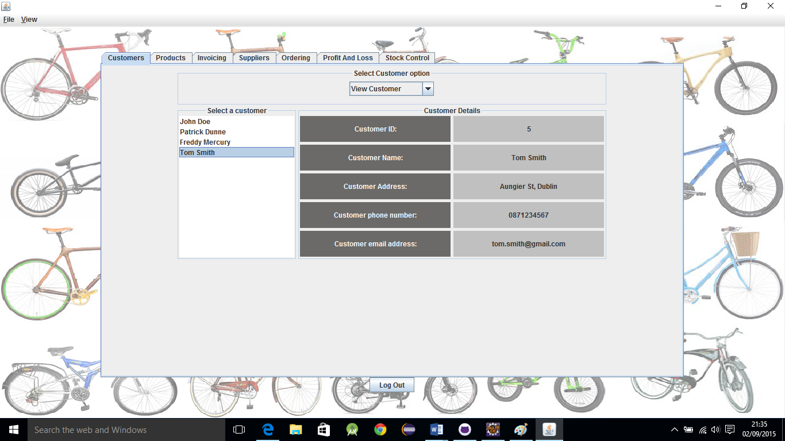

## 3.3 Edit or delete customers

To edit of delete customers from the system, select the “edit/delete customers” option from the combo box at the top of the card.

Customers can be selected from the list on the left. When a customer is selected, all their details are displayed on the right hand side. These details can be amended. When finishing editing details, press the save changes button to store the changes. A dialogue will appear asking to confirm changes being saved.

To delete a customer entirely from the system select the customer to be deleted from the list. When the required customer’s name is highlighted in the list and their details are displayed in the fields, press the delete customer button. A dialogue will appear asking to confirm deletion.

**Figure 3.3.1: The Edit/Delete Customer Card. Note buttons to save changed or delete customer.**

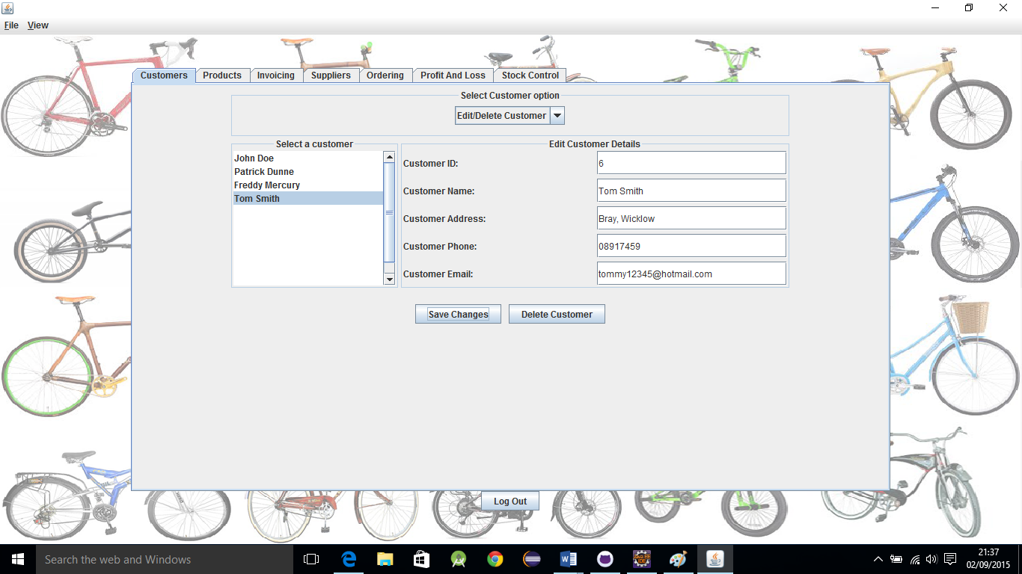

**Figure 3.3.2: Confirm dialogue when deleting a customer**

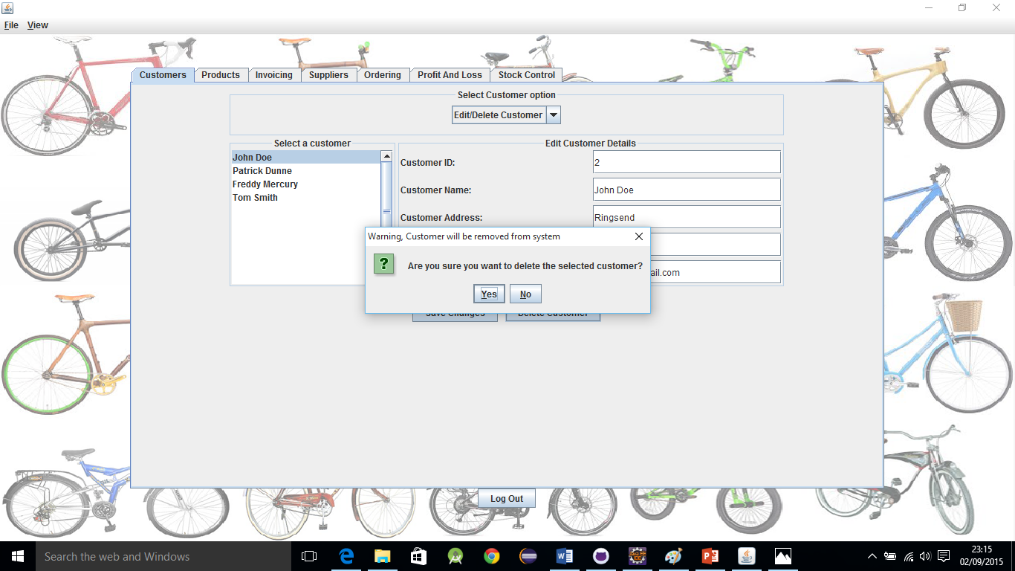

# 4.0 Ordering

## 4.1 Ordering from supplier

To place an order from a supplier, select the “Ordering” tab while logged in as a manager. Select the “Order from Supplier” option from the combo box.

The order from supplier card allows users to browse through the products available from suppliers, and add the products to a shopping basket.

First select a product type from the combo box labelled “Select Product type”. After selecting a product type from the combo box, the combo box below it labelled “Select Model” will be filled with all available bicycles of the selected type.

After selecting a product type and model, all available suppliers who stock that model bicycle will be displayed in the combo box labelled “Select Supplier”.

Lastly select the quantity to be ordered and press the “Add to Cart” button to add the product to the shopping cart.

**Figure 4.1.1: The Order from Supplier card layout.**

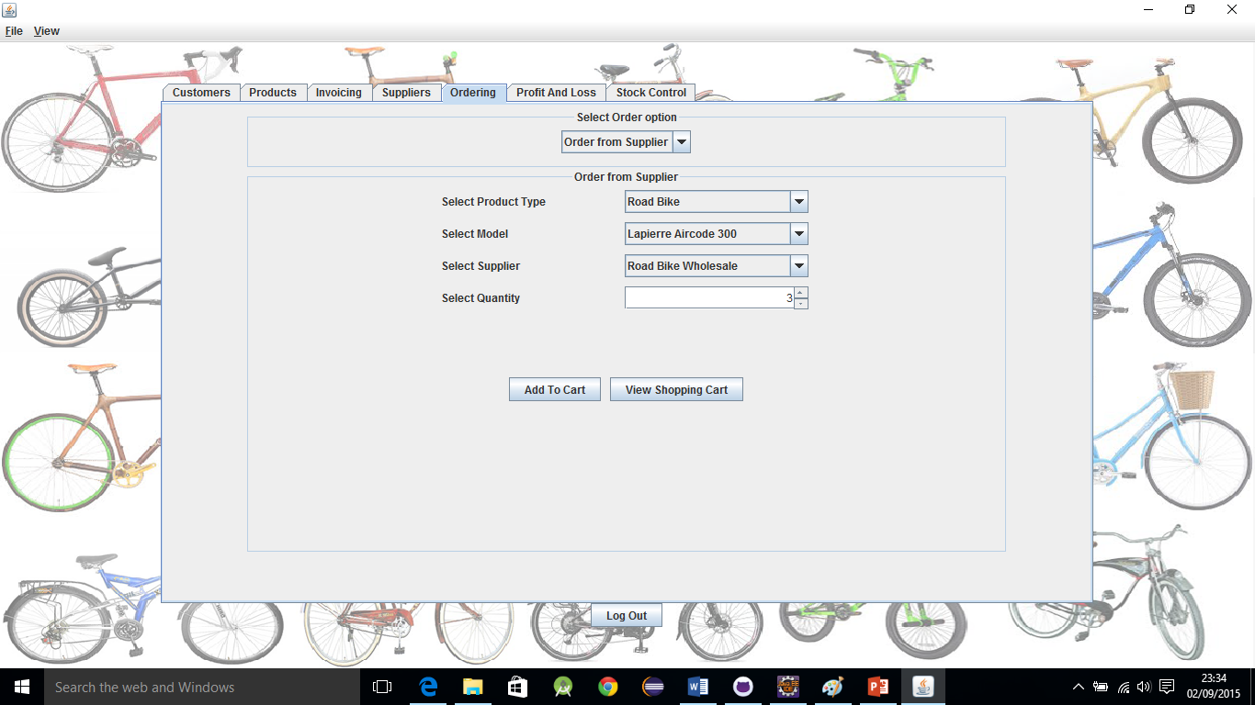

#### Supplier limit when shopping cart is not empty

Once an order has been placed in the shopping cart a different supplier cannot be selected until the shopping cart has been processed or discarded. This is to avoid mixing different suppliers into one order. Orders to different suppliers must be processed separately.

### 4.1.1 Shopping Cart

To view the shopping cart, press the “View Shopping Cart” button. The shopping cart consists of a transaction id field which is automatically generated in a similar way to customer id, and a product details table.

The product details table displays all bicycles which have been added to the cart. The supplier name and quantity are also displayed.

To process the order press the “Process Order” button. To cancel the order press the “Discard Order” button. To return to the previous order from supplier card, press the “Return to product order” button. This will not affect the products in the shopping cart and more products can be added to the order.

**Figure 4.1.2: The shopping cart. Note auto generated transaction id and product details table**

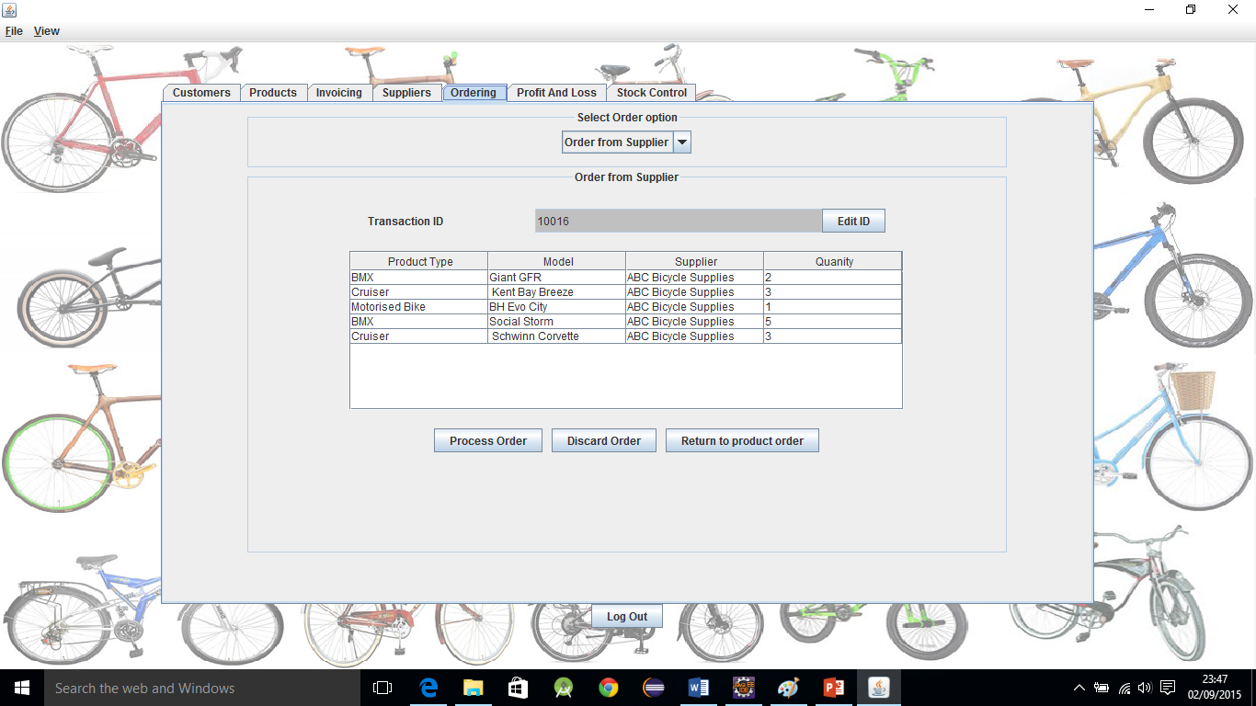

**Figure 4.1.3: Confirmation that an order has been submitted**

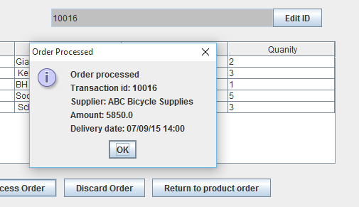

## 4.2 View Orders in system

**Figure 4.2.1: The View Orders card. Note table on left containing list of orders, order details in grid on above right and product details table below right**

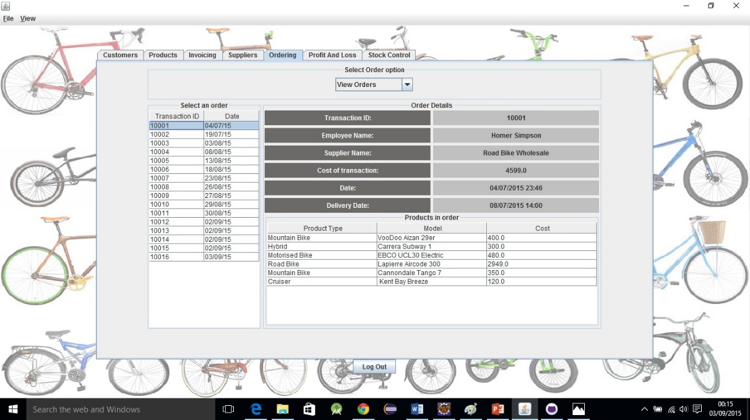

The view orders card allows users to view all orders in the system. The transaction id and date of the orders are displayed in the table on the right. When a row from the table is clicked, all details of that order will be displayed.

The details such as employee name, supplier name, the total cost of transaction, date and delivery date are displayed in the grid on the right.

The product details table is displayed below right. The product details contains all bicycles that are in the order and their cost. The product details table is a scrollable pane so more rows of products can be stored than the amount that can fit in the visible area.

## 4.3 View Old Orders

The view old orders card is very similar in appearance and use to the view orders card. The view old orders card only contains orders where the delivery date specified has already passed.

**Figure 4.3.1: The view old orders card layout**

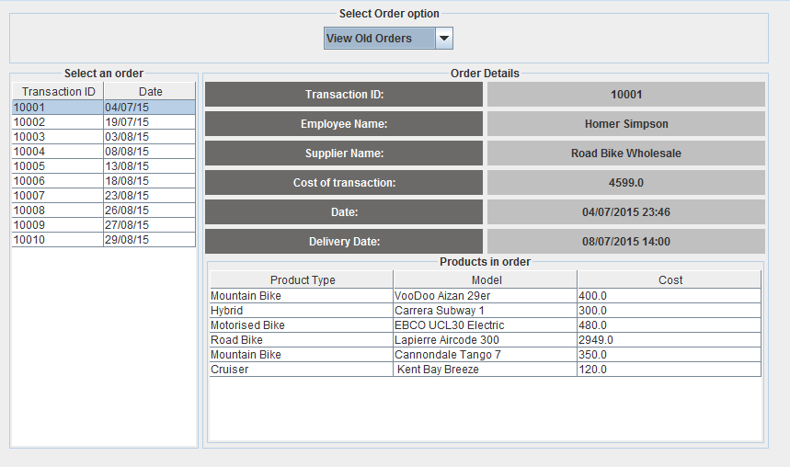

## 4.4 View Delivery Dates

The view delivery dates card allows managers to view upcoming delivery dates in the system. All orders where the delivery date has not yet passed the current date will be displayed in the “Upcoming deliveries” table at the top.

The upcoming deliveries table displays the transaction id, expected delivery date, order date, supplier, employee and cost of order.

Rows from the upcoming deliveries table can be selected to view the contents of the order. The contents of the order are displayed in the product details table below. The product details table displays the product type, product model and cost of product.

The view delivery dates card is displayed in figure 4.4.1.

**Figure 4.4.1: The view delivery dates card. Note the upcoming deliveries table above and product details table below.**

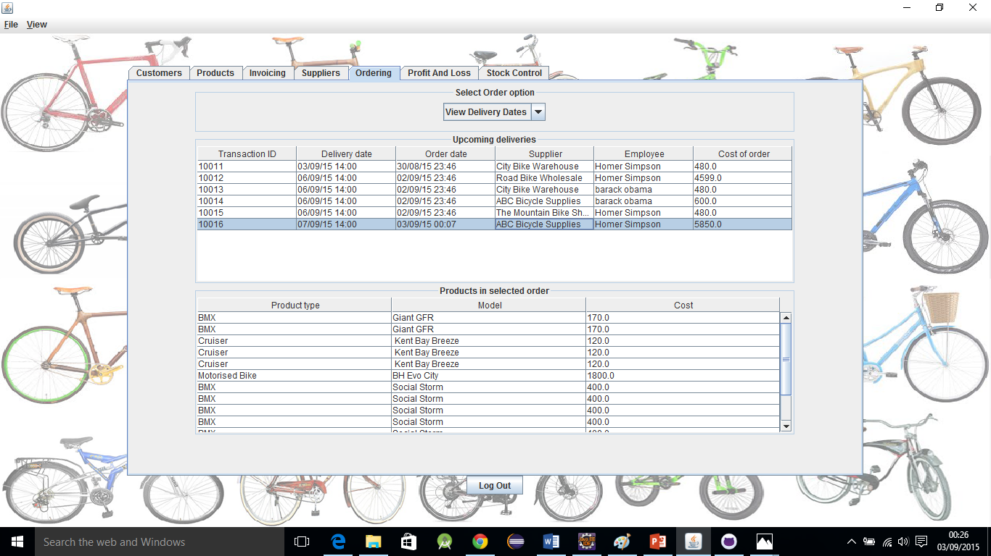

## 4.5 View costs

### 4.5.1 Costs of orders over time

The costs of orders over time card allows managers to view their all-time average weekly costs or their average over the last six weeks. These values are displayed in the grid above the chart.

The line chart provides managers with a visual representation of the costs of orders over the last six weeks. This allows them to quickly assess their recent expenditures.

**Figure 4.5.1: The view costs of orders over time card. Note average values for all time and over the last six weeks above chart. Also note chart provides visual representation of last six weeks orders.**

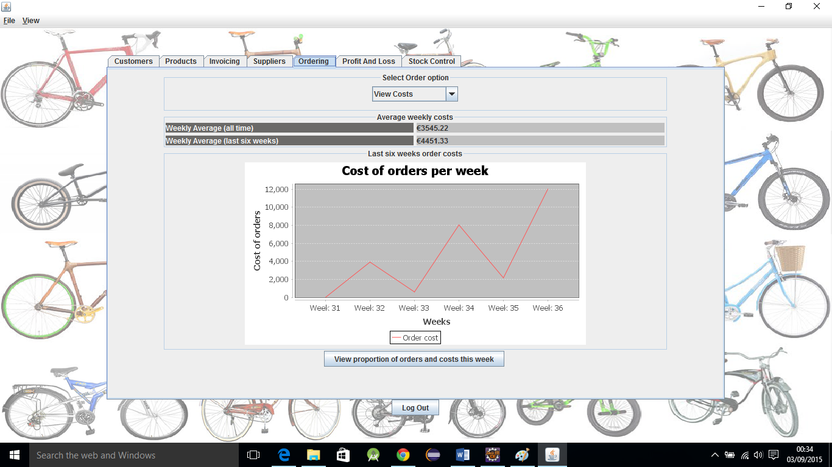

To view the cost of current week’s orders and its proportions to total orders in the system press the “View proportions of orders and costs this week” button.

#### Use of JFreeChart libraries

The line charts on this page and pie charts on the following page were created using JFreeChart libraries. JFreeChart is open source and distributed under the GNU Lesser General Public License.

Libraries retrieved from:  
<http://www.jfree.org/jfreechart/>

### 4.5.2 View this week’s costs and proportions

The view this week's costs and proportions allows managers to see the total number of orders in the system, the number of orders this week, the total cost of all orders in the system, and the total cost of this week’s orders. These values are all displayed in the grid section above the pie charts.

The pie charts below provide managers with an easy to read visual representation of the number or orders this week in comparison to total orders and the cost of orders this week compared to the cost of all orders in the system.

The pie chart on the left covers the numbers of orders in the system. The pie chart on the right covers the costs of orders in the system.

**Figure 4.5.2: The view this week’s costs and proportions card. Note grid above charts contains number of orders in system and costs of orders in system.**

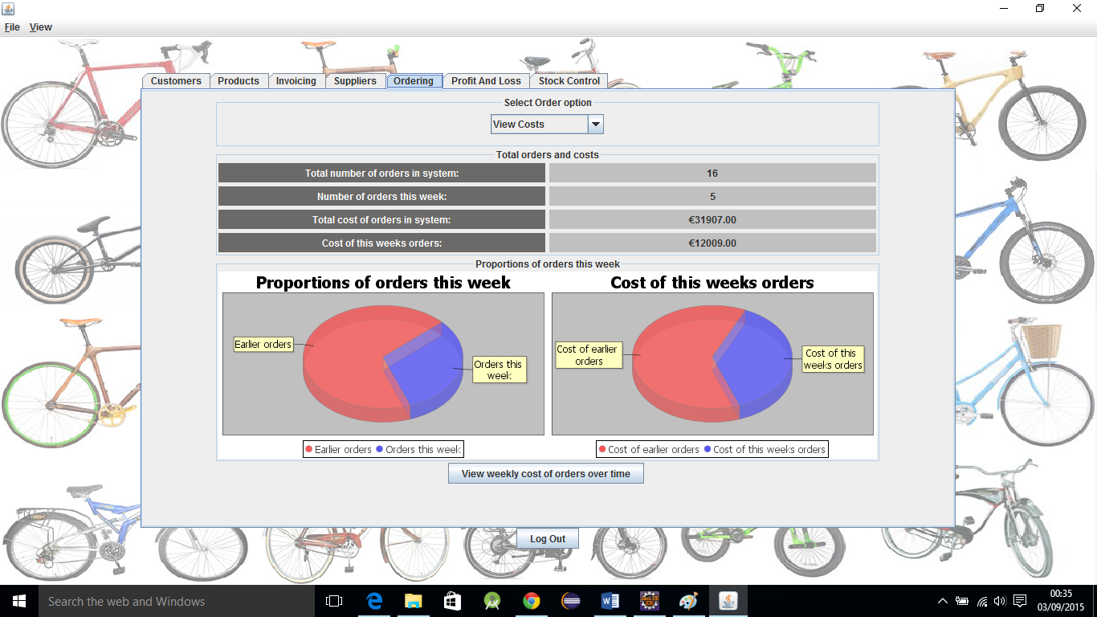

To return to the previous card press the "View weekly costs or orders over time” button.

# 5.0 Menu Bar

## 5.1 File Menu Items

The file menu contains options to log out of the system or to exit the program altogether. There are accelerator commands provided to allow fast execution of the options with the keyboard.

Shortcuts commands are:

* Ctrl + shift + L to log out of system
* Ctrl + shift + X to exit the program

### 5.1.1 Keyboard Mnemonics

There are keyboard mnemonics to allow easy access to the file menu.

* Alt + F to access the file menu
  + L to log out of the system after the file menu has been selected
  + X to exit the system after the file menu has been selected

**Figure 5.1.1: The file menu items. Note accelerator commands to allow use of keyboard shortcuts**

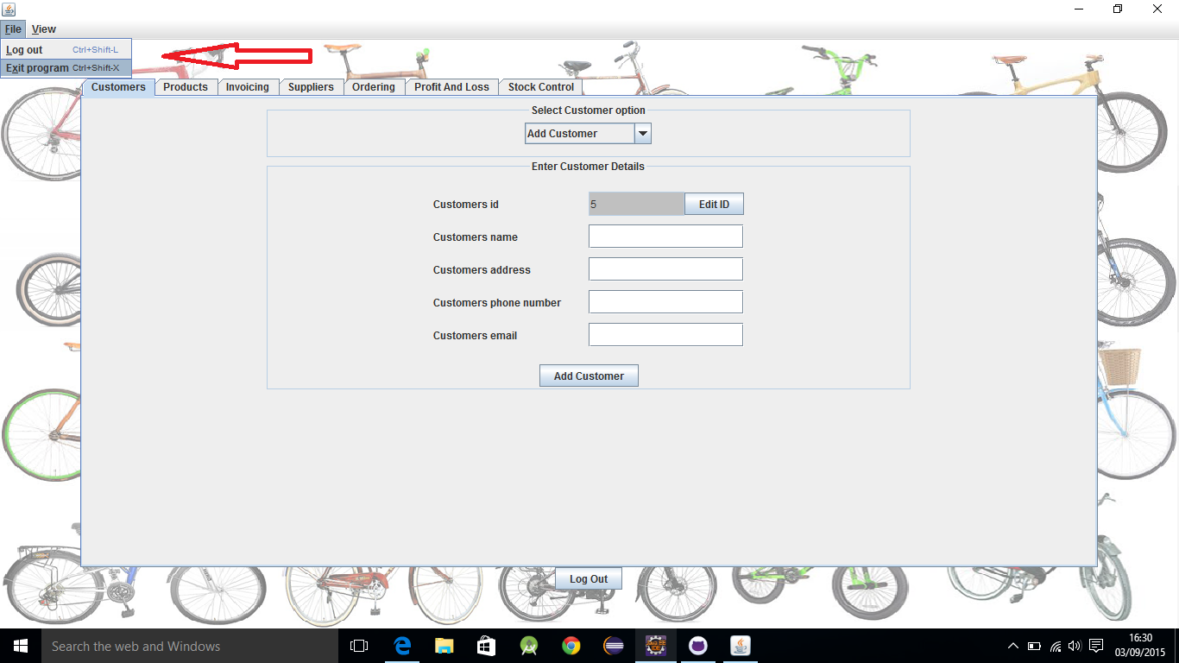

## 5.2 View Menu Items

The view menu allows uses to shrink the application window to a smaller size or to go back to full screen. Like the file menu, the view menu also has accelerator key commands defined to allow quick access.

Keyboard accelerator shortcuts:

* Ctrl + Shift + S to shrink the window to a smaller size
* Ctrl + Shift + F to go back to full screen

### 5.2.1 Keyboard mnemonics

There are keyboard mnemonics to allow easy access to the view menu.

* Alt + V to access the view menu
  + S to shrink the window after the view menu has been selected
  + F to go back to full screen after the view menu has been selected

**Figure 5.2.1: The view menu items**

